Crystal Structure Report for Eric Watson
by Werner Kaminsky
Sample
ID – watson01bLowT and morphology
X-ray Crystallography Laboratory
University of Washington
30. July 2026

Data backup accessibly through http:
URL: http://cad4.cpac.washington.edu/structures
Username: xray-user
Password: hkl-data

W.Kaminsky: tel. (206) 543 7585
(x-ray lab): tel. (206) 543 0210
Email: kaminsky@chem.washington.edu

Understanding crystallographic information is not trivial. If you discuss a structure in a publication, please let the crystallographers proof-read the final draft of that manuscript before you submit it.
For many structures it is true that crystallography is an intellectual performance (like synthesis or elucidation of mechanisms) and not a routine job. In these cases, particularly when the structures contribute significantly to the content of the publication, the crystallographers should be co-authors. Do not think this is not necessary because you pay for structures. Even I have to pay for my own structures for my research.
A piece of a green prism that chattered into pieces upon cooling, measuring 0.05 x 0.05 x 0.05 mm³ was mounted on a glass capillary with oil. Data was collected at -173ºC on a Bruker APEX II single crystal X-ray diffractometer, Mo-radiation.

Crystal-to-detector distance was 40 mm and exposure time was 240 seconds per frame for all sets. The scan width was 2º. Data collection was 100% complete to 25º in ϑ. A total of 19466 (merged) reflections were collected covering the indices, h = -16 to 16, k = -10 to 10, l = -21 to 21. 1859 reflections were symmetry independent and the R_{int} = 0.1041 indicated that the data was of slightly less than average quality (0.07). Indexing and unit cell refinement indicated a C -centered monoclinic lattice. The space group was found to be C 2/c (No.15).

The data was integrated and scaled using SAINT, SADABS within the APEX2 software package by Bruker.

Solution by direct methods (SHELXS, SIR97) produced a complete heavy atom phasing model consistent with the proposed structure. The structure was completed by difference Fourier synthesis with SHELXL97., Scattering factors are from Waasmair and Kirfel. Hydrogen atoms were placed in geometrically idealised positions and constrained to ride on their parent atoms with C---H distances in the range 0.95-1.00 Angstrom. Isotropic thermal parameters U_{eq} were fixed such that they were 1.2U_{eq} of their parent atom Ueq for CH's and 1.5U_{eq} of their parent atom U_{eq} in case of methyl groups. All non-hydrogen atoms were refined anisotropically by full-matrix least-squares.

The BF4⁻ appears disordered. Otherwise the structure is very similar to that at room temperature.

The structure is of high quality and ready for publication. Table 1 summarizes the data collection details. Figure 1 shows an ORTEP of the asymmetric unit.

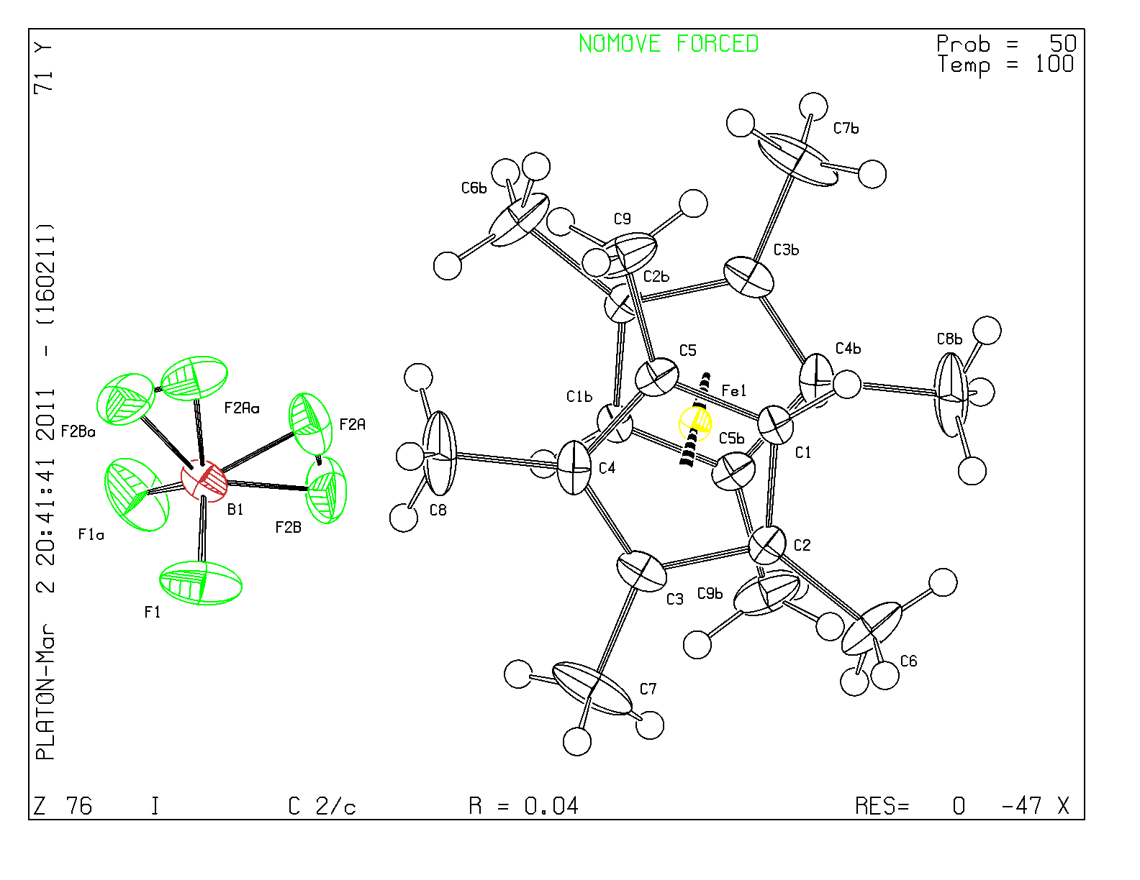
Figure 1. ORTEP of the structure with thermal ellipsoids at the 50% probability level.

Table 1: Crystallographic data for the structures provided.
Empirical formula C18 H26 B F4 Fe
Formula weight 385.05
Temperature 100(2) K
Wavelength 0.71073 Å
Crystal system Monoclinic
Space group C 2/c
Unit cell dimensions a = 13.4154(4) Å α= 90°.
b = 7.9607(4) Å β= 108.941(4)°.
c = 17.3510(8) Å γ = 90°.
Volume 1752.68(13) Å3
Z 4
Density (calculated) 1.459 Mg/m3
Absorption coefficient 0.896 mm-1
F(000) 804
Crystal size 0.05 x 0.05 x 0.05 mm3
Theta range for data collection 2.48 to 26.82°.
Index ranges -16<=h<=16, -10<=k<=10, -21<=l<=21
Reflections collected 19466
Independent reflections 1859 [R(int) = 0.1041]
Completeness to theta = 25.00° 100.0 %
Max. and min. transmission 0.9566 and 0.9566
Refinement method Full-matrix least-squares on F2
Data / restraints / parameters 1859 / 0 / 124
Goodness-of-fit on F2 1.036
Final R indices [I>2sigma(I)] R1 = 0.0406, wR2 = 0.0705
R indices (all data) R1 = 0.0797, wR2 = 0.0817
Largest diff. peak and hole 0.361 and -0.401 e.Å-3

Differences between structures

The batch contained similar looking green prisms and thin plates. Indexing of 10 samples revealed that the plates and most of the more compact green plates were identical. They indexed at room temperature and 100K in the space group P 2₁/n with
unit cell dimensions (100K, report watson01a) a = 8.2561(3) Å α= 90°.
b = 8.4486(3) Å β= 93.997(2)°.
c = 25.6780(9) Å γ = 90°.
Volume 1786.75(11) Å3

For these crystals, ferrocenes are rotated by about 73 degrees towards each other and BF₄⁻ appears disordered.

One prism however was found which indexed at room temperature and 100K in the space group C 2/c
Unit cell dimensions (100K, this report) a = 13.4154(4) Å α= 90°.
b = 7.9607(4) Å β= 108.941(4)°.
c = 17.3510(8) Å γ = 90°.
Volume 1752.68(13) Å3

Strikingly, the crystal crumbled upon cooling, likely due to a large change in monoclinic angle of almost 1 degree.
For these crystals, ferrocenes are rotated by 180 degrees towards each other, BF₄⁻ appears definitely disordered at 100K, however at 100K it was treated with slightly larger than normal thermal ellipsoids (see report: watson01b).

Images below (Figure 2) show the indexed (idealized) morphologies (WinXmorph). Simulation with the Bravais-Friedel; Donnay-Harker model with WinXmorph revealed all indexed faces, but in different order of importance, indicating strong directional bonding characteristics of the structures which in both cases exhibit alternating layers of BF₄⁻ and the iron complex.

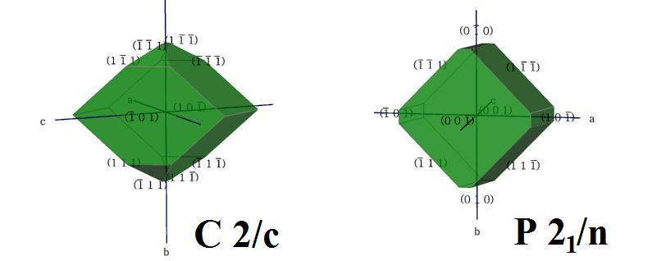
Figure 2. Idealized crystal morphologies of the crystals from which structures were derived.

References

Bruker (2007) APEX2 (Version 2.1-4), SAINT (version 7.34A), SADABS (version 2007/4), BrukerAXS Inc, Madison, Wisconsin, USA.
(a) Altomare A, Burla C, Camalli M, Cascarano L, Giacovazzo C, Guagliardi A, Moliterni AGG, Polidori G, Spagna R. (1999) SIR97: a new tool for crystal structure determination and refinement Journal of Applied Crystallography, 32, 115-119. (b) Altomare A, Cascarano G, Giacovazzo C, Guagliardi A. (1993) Completion and refinement of crystal structures with SIR 92. Journal of Applied Crystallography, 26, 343-350.
Sheldrick GM. (1997) SHELXL-97, Program for the Refinement of Crystal Structures. University of Göttingen, Germany.
Mackay, S.; Edwards, C.; Henderson, A.; Gilmore, C.; Stewart, N.; Shankland, K.; Donald, A. (1997) MaXus: a computer program for the solution and refinement of crystal structures from diffraction data. University of Glasgow, Scotland,.
Waasmaier, D.; Kirfel, A. (1995) New Analytical Scattering Factor Functions for Free Atoms and Ions. Acta Crystallographica A., 51, 416-430.
Farrugia LJ. (1997) Ortep-3 for Windows. Journal of Applied Crystallography, 30, 565
a) W. Kaminsky. (2005) WinXMorph: a computer program to draw crystal morphology, growth sectors and cross-sections with export files in VRML V2.0 utf8-virtual reality format. J Journal of Applied Crystallography, 38 ,566-567. b) W. Kaminsky. (2007) From *.cif to virtual morphology: new aspects of predicting crystal shapes as part of the WinXMorph program. J. Appl. Cryst., 40, 382-385.

