ST6901

The crystal structure of [LutH⁺][HC(=O)B(C₆F₅)₃⁻] was established with a Nonius Kappa
CCD FR590 single crystal X-ray diffractometer. A colorless prism measuring 0.60 x 0.24 x 0.20 mm³ was mounted on a glass capillary with paratone oil as adhesive. Data was collected at 130(3)K. The crystal-to-detector distance was set to 31.5 mm and the exposure time was 180 seconds for each collected frame. The scan width was 1.8º. Data collection was 99.3% complete to 25º in ϑ. A total of 58919 partial and complete reflections were collected covering the indices, h = -47 to 47, k = -16 to 17, l = -24 to 24. 9314 symmetry independent reflections resulted from integration with hkl-SCALEPACK which applies a multiplicative correction factor (S) to the observed intensities (I) and has the following form:

S is calculated from the scale and the B factor determined for each frame and is then applied to I to give the corrected intensity (I_{corr}). The data in monoclinic space group C 2/c was of average quality (R_{int} = 0.065). The structure was solved with direct methods within SIR97 and refined with SHELXL97. Scattering factors are from Waasmair and Kirfel. All hydrogen atoms were located using a riding model. All non-hydrogen atoms were refined anisotropically by full-matrix least-squares. Crystallographic data is provided in table 1.

The asymmetric unit contains two symmetry independent [LutH⁺][HC(=O)B(C₆F₅)₃⁻] salt molecules. 8 of these salts fill the unit cell. The fluorides tend to exhibit a larger thermal motion than the carbon ring atoms. Some fluorides are forced into close contact (F9-F18 F20-F20’). N2 hydrogen bonds within the asymmetric unit to O4, N1 inter-molecularly to O2 of a symmetry related unit (table 2).

Table 1: Crystallographic data for [LutH⁺][HC(=O)B(C₆F₅)₃⁻]
Property | The structure at 130(2) K
Empirical Formula | C₂₆H₁₁B₁F₁₅N₁O₂
Formula Weight | 665.17
Temperature K | 130(2)
Wavelength Å | 0.71073
Habit/color | Prism / colorless
Crystal System, space group | monoclinic, C 2/c (No.15)
Unit Cell Dimensions
a, Å  b, Å  c, Å  β, (deg.) | 39.4325(9)  14.2833(4)  20.3561(7)  116.8621(12)
Volume (Å³) | 10228.0(5)
Density Mg/m³ | 1.728
Reflections Collected/Unique | 17004 / 9314
Rint / Rσ | 0.0655/ 0.0918
ϑm / completeness | 25º / 99.3%
Final R indices [I>2σ(I)]
R1, wR2 | 0.0509, 0.1023
R indices (all data)
R1,wR2 | 0.1169, *wR2 = 0.1269

Table 2. Hydrogen bonds for shelxl [Å and °].
____________________________________________________________________________
D-H...A d(D-H) d(H...A) d(D...A) <(DHA)
____________________________________________________________________________
N(2)-H(2)...O(4) 0.88 1.90 2.774(3) 170.0
N(1)-H(1B)...O(2)#1 0.88 1.91 2.786(3) 171.2
____________________________________________________________________________
Symmetry transformations used to generate equivalent atoms:
#1 x,-y+1,z-1/2

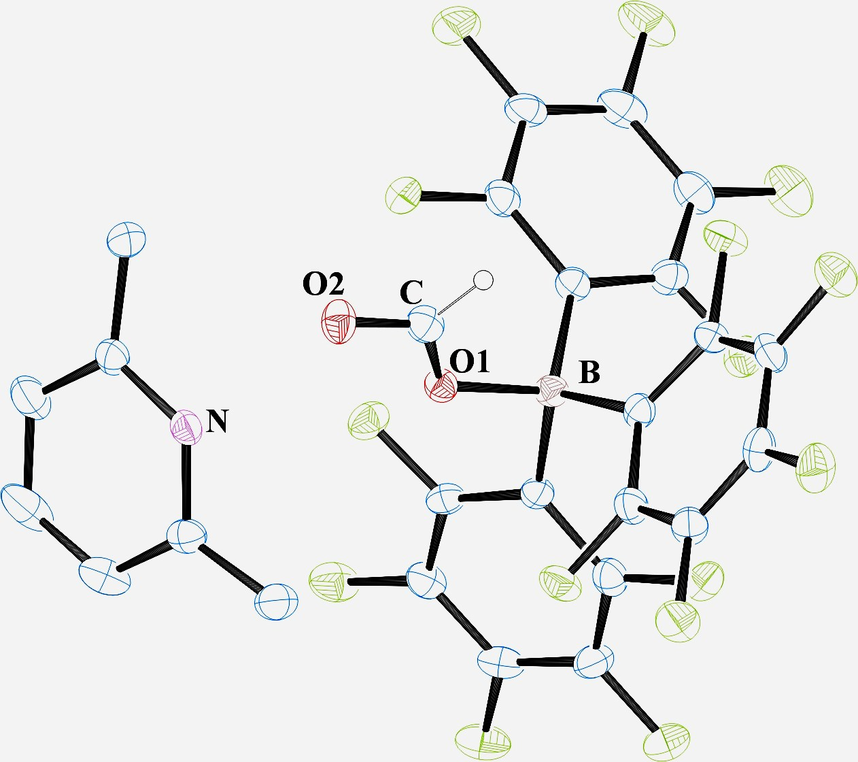

Figure 1. ORTEP drawing of [LutH⁺][HC(=O)B(C₆F₅)₃⁻] with thermal ellipsoids at their 50% probability level.

(a) Z. Otwinowsky, W. Minor, Methods Enzymol. 276, 307 (1997). (b) S. Mackay, C. Edwards, A. Henderson, C. Gilmore, N. Stewart, K. Shankland, A. Donald, University of Glasgow, Scotland, 1997.
A. Altomare, C. Burla, M. Camalli L. Cascarano, C. Giacovazzo, A. Guagliardi, A. G. G. Moliterni, G. Polidori, R. Spagna, J. Appl. Cryst. 32, 115 (1999).
G, M. Sheldrick, SHELXTL97, University of Gottingen, Germany (1997).
D. Waasmaier, A. Kirfel, Acta Crystallogr. A. 51, 416 (1995).
Farrugia, L. J. Appl. Cryst. 1997, 30, 565

