Structure solution of TpOs(NS)(OAc)₂ (4)

Crystals of 4 were grown from M2₂CO/Et₂O solutions. The diffraction data for 4 (Nonius Kappa CCD, Mo-radiation) was integrated with the DENZO2000 software package []. The indexing procedure reveeled an orthogonal symmetry with lattice parameters of 9.2380(6) Å, 15.1010(10) Å, and 13.3830(10) Å. We did not observe evidence for a larger lattice in the raw data, however, none of the direct solutions obtained with either SHELXS,[] DIRDIF,[] or SIR97[] gave a chemically meaningful result, showing a single osmium sorrounded by electron density maxima, many of which were less than 1 Å apart. Attempts to index with a larger unit cell did not change these findings. The material clearly was of high quality showing well difined extinction between crossed polars and, thus, certainly was crystalline with a regular lattice.
When comparing the found electron density with the proposed chemical composition we came to the conclusion that the whole molecule must be disordered involving a mirror plane cutting through the electron density and that a solution of this relatively dificult problem would be of general interest despite a limited amount of scientific usuful information obtainable since bond distances and thermal parameters would need several restraints to prevent the refinement of such a heavily disordered structure to diverge.
That aforementioned mirror plane is part of the crystallographic space group symmetry elements in (P b c m) and cuts through C1, C2, Os1, C13 (Figure 4) which divides the electron density found for the whole crystal into one belonging to a left-handed and the other to a right-handed version of the molecule. The molecule shown in Figure 4 thus appears twice in the asymmetric unit where each atom has half-site occupancy. Disorder is brought about by a statistical distribution of the left- and right-handed molecules accross the mirror plane, leaving the totatal symmetry centrosymmetrical.
The refinement (employing SCHELXL97 []) in this case of disorder was stabalized by applying 'soft' limits to the range within a parameter can vary. Close vicinity of electron density maxima was for example caused by the atomic positions of the acetate (O1, C10, C11, O2) to be convolved with those of the thionitrosyl (N7, S1) and the other acetate was convolved with itself (O3, C12, C13, O4). The positional and thermal parameters of each atom and the close neigbours were strongly correlated. Similarily some of the atoms of the Tp moity were too close for a free refinement of the thermal and positional parameters (Figure XX).
The following restraints were applied to reduce these correlations:

Restraint | Atoms involved | Value | Number of restraint parameters / object | Total restraints
Distance | C10-C11, C12-C13 | 1.54(2) Å | 1 (C13 is on mirror) | 1
Distance | C10-O2, C12-O4 | 1.22(2) Å | 1 | 2
Distance | C10-O1, C12-O3 | 1.37(2) Å | 1 | 2
Distance | C13-O4, C13-O3 | 2.40(2) Å | 1 (C13 is on mirror) | 1
Planarity | O1, C10, O2, C11 | 0.1 STD | 1 | 1
Planarity | O3, C12, O4, C13 | 0.1 STD | 1 | 1
Probability Volumes | O1, N5, N6, N7, C6, C7, C8, C10, C11 | 0.007 STD | 4 | 56
 |  |  |  | 64

The largest number of restraints resulted from restraining the thermal parameters. This seemed the most objective way to unfold the two convolved molecules. The other restraints were applied according to well known molecular properties of the acetates, guided by the principle not to introduce any properties to the molecule that are not otherwise well supported.
Still, some of the distances in the model showed the effect of disorder: the distance between N7 and S1 with 1.62(2) Å appeared unusually large, where the maiority of Os^{II}-nitrosyls had shorter distances of ....... (Please paste the other values plus citations) . We believe that the refinement of N7 in vicinity of the disorder-related OAc caused the bond towards the Os to appear about 0.1 Å shorter than would be expected and that of S1 towards the Os to be refined 0.1 Å larger. The Os-N-S angle in 4 however was less affected by the disorder and showed a value well in the range of thos of ....... (Please paste the other values plus citations) .
This discussion showed that those values given in Table 2 are to a certain degree distorted, and that the refinement of highly disordered molecules need to be carefully examined. Yet, although less of value for the discussion of bond distances and angles, such a case should not be treated as a badly refined structure (rest electron density: −1.557 eÅ⁻³ to 0.197 eÅ⁻³), but as an intrinsically problematic case of crystallinity that makes the search for chemically relevant data more difficult.
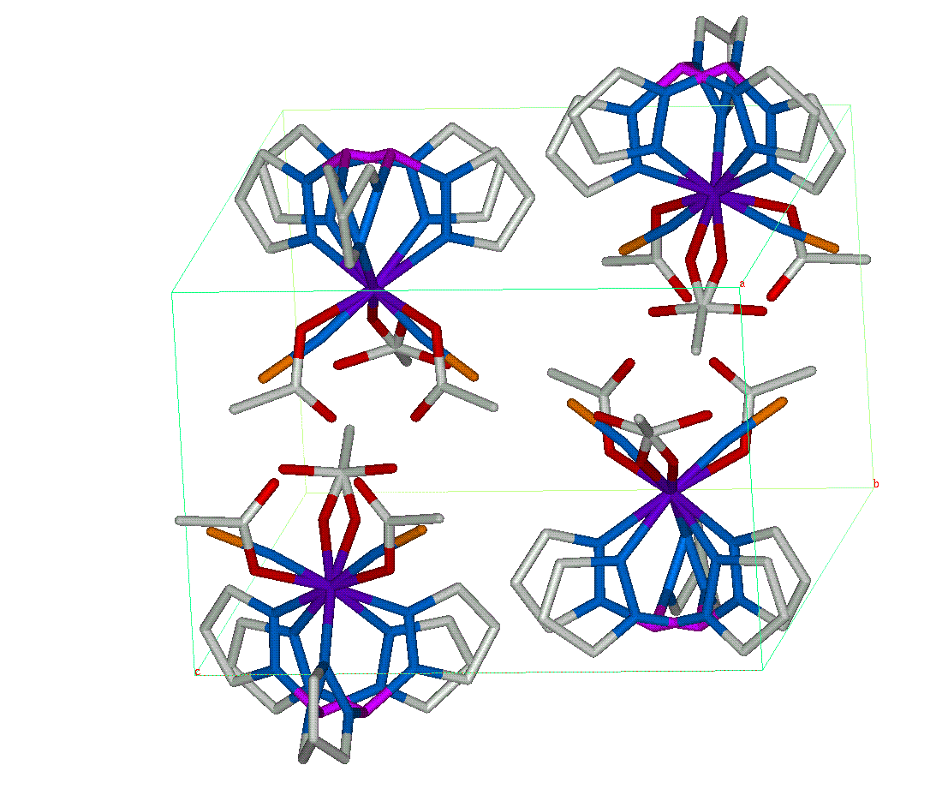Figure XX: The unit cell of 4 with symmetry operations applied to the molecule from Figure 4.

Z. Otwinowski and W. Minor, " Processing of X-ray Diffraction Data Collected in Oscillation Mode ", Methods in Enzymology, Volume 276: Macromolecular Crystallography, part A, p.307-326, 1997,C.W. Carter, Jr. & R. M. Sweet, Eds., Academic Press (New York).
SHELXS (direct methods): Sheldrick, G. M. (1990). Phase annealing inSHELX-90: direct methods for larger structures. Acta Cryst. A46, 467â€“473.SHELXS (Patterson): Sheldrick, G. M., Dauter, Z., Wilson, K. S., Hope,H. & Sieker, L. C. (1993). The application of direct methods and Patterson interpretation to high-resolution native protein data. Acta Cryst. D49, 18â€“23.
Beurskens, P.T., Admiraal, G., Beurskens, G., Bosman, W. P., Garcia-Granada, S., Gould, R. O., Smits, J. M. M. & Smykalla, C. (1996) The DIRDIF96 Program System. Technical Report of the Crystallography Laboratory, University of Nijmegen, The Netherlands.
Altomare, A.; Cascarano, G.; Giacovazzo, C.; Burla, M.C.; Polidori, G.; Camalli, M. (1994) J. Appl. Cryst. 27, 435-442.
SHELXL (refinement): Sheldrick, G. M. & Schneider, T. R. (1997) University of G\"ottingen, Germany. SHELXL: high resolution refinement. Methods in Enzymology, 277, edited by C. W.Carter, Jr. & R. M. Sweet, pp. 319â€“343. San Diego: Academic Press.

