The absolute optical configuration for a given crystal structure in this case has to specify in which direction any, for example, positive optical rotation has been observed (Glazer, A.M.; K. Stadnicka, 1989). A tensorial property is given in reference to the assignment of the physical reference system e_{i} which, by convention, is related to the crystallographic axes a, b and c (see for example Haussühl 1983), like

e₂ // b*, e₃ // c, e₁ // e₂ x e₃. 1

Table 1. Observed and calculated Friedel differences for the CsLiB₆O₁₀ sample used in the optical rotation and X-ray anomalous scattering experiment. The calculated differences (>5%) are based on the structural coordinates in Table 2.

h k l | _{I(hkl)} | I$(k\overline{h}l)$ | ΔI/I^{observed}(%) | ΔI/I^{calculated}(%)
1 1 2 | not | observed
3 2 3 | 14592(282) | 15901(333) | -8.6(2.6) | +15.06
4 3 1 | 6796(120) | 7163(127) | -5.3(2.4) | +15.64
4 1 3 | 20657(321) | 20962(365) | -1.5(2.3) | +5.54
2 2 4 | 39667(1508) | 34494(991) | +14.0(4.5) | -14.18
5 2 1 | 28248(504) | 27815(600) | +1.6(2.8) | -10.62
4 3 3 | 29829(620) | 32796(694) | -9.6(2.9) | -7.87
6 1 1 | 12544(258) | 13386(287) | -6.5(3.0) | -10.13
5 4 1 | 16781(335)) | 17795(369) | -6.0(2.9) | 9.64
4 1 5 | 16494(275) | 16934(443) | -2.7(2.5) | -10.79
6 3 3 | 3067(69) | 3291(63) | 7.2(2.8) | 11.04

When assigning the indices to the faces of a crystal, it is convenient to calculate first the intensity-difference of scattered X-rays between pairs (hkl) and $(k\overline{h}l)$ from the known structural model:

$ΔII=\frac{I(\text{hkl})−I(\bar{h}\bar{k}\bar{l})}{\frac{1}{2}(I(\text{hkl})+I(\bar{h}\bar{k}\bar{l}))}$. 1

This helps to find out, which of them are significant even before starting to collect the X-ray intensity data. The crystal structure coordinates in Table 2 were taken as a reference. The calculated differences, using the program ‘Crystallographica’ (Oxford Cryosystems), are listed in Table 1. If the experiment shows the same differences by and large, the assignment of indices in the X-ray data can be taken as absolute. If the differences consistently exhibit the opposite sign, the indices have to be transformed to match the reference structure. Our observation is: 7 disaggreements and 3 agreements for Friedel pairs with expected difference larger than 5%. The Flack-enantiopole parameter was 0.72(24). The polished face through which the optical rotation was determined was assigned (0 1 0). by the software. Taking acount of the sensitive Friedel pairs and the Flack-enantiopole parameter which imply a rotation by 90 degrees around the c-axis, the polished face refers to the structure in Table 2 as a (100) - face.

Table 2. Atom coordinates for absolute indexing of the CsLiB₆O₁₀ – sample.

Atom | x/a | y/b | z/c
Cs1 | 0 | 0 | 0
Li1 | 0 | 0 | 0.5
B1 | 0.2326(7) | 0.1484(7) | 0.5601(9)
B2 | 0.25 | -0.0244(8) | 0.375
O1 | 0.1022(5) | 0.1444(5) | 0.5703(7)
O2 | 0.2994(7) | 0.25 | 0.625
O3 | 0.3020(5) | 0.0575(5) | 0.4948(7)

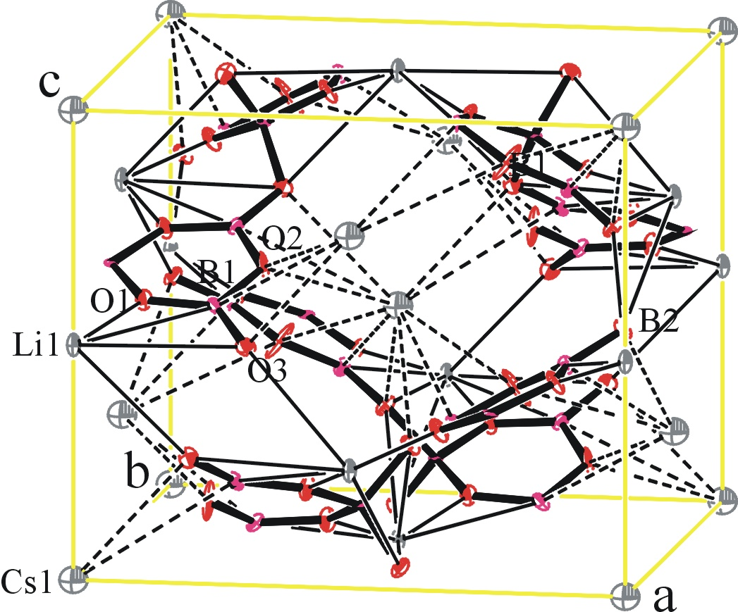
Figure 1. Ortep and packing diagram of CsLiB₆O₁₀ with thermal ellipsoids shown at their 50% probability. BO₃-units are drawn with bold black bonds. Li-O coordinations are represented by thin lines.The coordination sphere around Cs is drawn with dashed lines.

The colorless crystal was mounted in random orientation on a glass fiber on a Nonius Kappa CCD Diffractometer, MoKα (λ = 0.71073 Å). Cell constants and an orientation matrix for data collections were obtained by least squares refinements of the diffraction data from more than 100 reflections. The structures were solved by direct methods. Scattering factors are from Waasmaier and Kirfel [12]. The structures were solved with MaXus [13], structure refinement was carried out with SHELXL-97 [14] and the graphics used are Zortep [15]. Table 3 summarizes the crystal data, collection information and refinement data for these thioureas.
Table 3. Crystallographic data and methods of data collection, solution and refinement for CsLiB₆O₁₀
____________________________________________________________________________
Crystal Data | CsLiB₆O₁₀ | Formula weight | 364.700
Empirical Formula | Cs Li B6 O10 | Density (calcd.), g/cm³ | 2.478
Type of radiation and its wavelength | MoKα (λ = 0.71073 Å). | Absorp. coeff., mm⁻¹ | 3.825
Type of diffractometer used for data collection | Nonius Kappa-CCD Diffract. | F(000) | 672
Temperature | 293(2) | Index ranges | -13 < h < 13
Crystal Color, Habit | colorless, prism |  | -9 < k < 9
Crystal Size (mm) | 0.7x0.7x0.7 |  | -10 < l < 8
Crystal System | Tetragonal | θ range for data collection | 3.00 to 26.30
Space Group | 'I-42d' | Total reflections/parameters | 477 / 43
a, Å | 10.467(1) | Independent reflects., R_{int} | 477, 0.025
b, Å | 10.467(1) | Absorption correction | HKL-Scalepack
c, Å | 8.922(1) | Max. & min. transmissions | 0.9770 & 0.9461
α, ° | 90 | Goodness-of-Fit | 1.242
β, ° | 90 | Largest diff. peak eÅ-3 | 0.696
γ, ° | 90 | Largest diff.hole eÅ-3 | -1.518
Volume, Å³ | 977.4(1) | R₁, wR₂ | 0.0563, 0.1427
Z | 4 | R₁, wR₂ (all reflections) | 0.0563, 0.1437
_______________________________________________________________________________________________________________________________________________________________________________________

5. References

Glazer, A.M.; K. Stadnicka. On the use of the term 'absolute configuration' in crystallography. Acta Cryst. A45 (1989), 234-238.
Haussühl, S: Kristallphysik. Physik-Verlag, Verlag-Chemie, Weinheim 1983.
[12] D. Wassmaier, A. Kirfel, Acta Cryst. A51 (1995) 416.
[13] S. Mackay, C. Edwards, A. Henderson, C. Gilmore, N. Stewart, K. Shankland,
A. Donald, MAXUS, version 2, University of Glascow, Scotland, 1997.
[14] G. M. Sheldrick, SHELXL-97. Program for the Refinement of Crystal Structures, University of Göttingen, Germany, 1997.
[15] L. Zsolnai, G. Huttner, ZORTEP, University of Heidelberg, Germany, 1994.

