Palladium (II) Complexes containing Mixed donor ligands as Catalyst Precursors for Ethylene Oligomerization

Maliha Asma⁽¹⁾, Werner Kaminsky⁽²⁾ and Amin Badshah⁽¹⁾,
⁽¹⁾Department of Chemistry, Quaid-I-Azam University, Islamabad, Pakistan
⁽²⁾Department of Chemistry, University of Washington, Seattle, USA

ABSTRACT

A series of palladium (II) complexes (1-6) containing both N and P donor atoms have been synthesized and characterized by multinuclear (¹H, ¹³C) NMR, IR spectroscopy and elemental analysis. Complexes of 1, 2 and 6 were in addition analyzed by single crystal X-ray crystallography, which showed distinct ligand effects distorting the square planar coordination geometry around the Pd (II) center. Catalytic activity studies revealed that these complexes show moderate activity towards ethylene oligomerization when activated by co-catalyst methylaluminoxane (MAO).

1. INTRODUCTION

The chemistry of polyolefins is a rapidly growing area in polymer industry. Over the past decade attention on polyolefin catalysis employing transition metal catalysts has increased significantly. Late transition metal complexes are especially important because of a less oxophilic nature than their early transition metal equivalents. In 1995, Maurice Brookhart introduced for the first time cationic palladium (II) α-diimine catalysts for olefin polymerization to produce high molecular weight polymers []. β- diimine Pd (II) complexes, comparable to α-diimine Pd (II) complexes, produced highly branched amorphous polyethylene similar to the Brookhart’s α-diimine Pd (II) complex [].
The ligand architecture plays a significant role in the oligomerization and polymerization processes. In 1999, Kress and co-workers reported cationic Pd (II) complexes chelated by unsymmetrical bidentate ligands containing pyridyl and bulky 2, 6- diisopropylphenylimine moieties for oligomerization of olefins [,]. Recently, Mapolie and coworkers have reported a number of active palladium catalysts chelated by pyridinylimine along with a long chain aliphatic substituent at imino nitrogen and pyridine linker pyrazolyl ligands and described as active catalysts for polymerization of ethylene after activation with MAO [, , , ]. However, in case of Pd (II) complexes with alkane bridged macrocyclic ligands the catalytic activity was found to be low due to significant steric hindrance at the catalytic center []. Similarly, various palladium (II) complexes containing P,N ligands based on quinoline, π-accepting N-pyrrolyl and N, N, N/, N/-tetrakis(diphenylphosphanyl)1,3-diaminobenzene were investigated for copolymerization of CO with styrene and ethylene and ethane or ethylidenenorbornen respectively [,]. Various P^O bidentate [] and tridentate P^N^O [] ligands chelated to palladium (II) were designed to investigate oligomerization of ethylene. N^N for olefin polymerization [] and mixed P^N 2-(2-pyridyl)phospholes containing palladium complexes were employed to study copolymerization of CO and ethylene []. Similarly, N^N diimine containing palladium complexes were subjected to study the reaction of vinylacetate and other unsaturated acetates like trifluoro acetates, reacted with ethylene []. Cationic palladium complexes were also reported by Brookhart et al. to successfully copolymerize ethylene and olefin with methacrylate and alternated copolymerization of ethylene and CO [,]. In 2004, Joachim Heinicke et al., reported the impact of various phosphorus additives like o-, m-, p-tolylphosphine along with some catalysts on oligomerization of ethylene []
We report herein, synthesis and structural characterization of a series of new phenylphosphine and tolylphosphine based palladium (II) complexes ligated with substituted anilines. Here, we used substituted phosphines ligated to Palladium (II) to study their specific influence on ethylene. These complexes were evaluated as moderate catalysts for ethylene oligomerization.

X= Cl

complex | 1 | 2 | 3 | 4 | 5 | 6
L1 | Ph₃P | T,p,Tp | T,p,TP | T,p,TP | T,p,TP | T,p,TP
L2 | N-methylaniline | DCHA | 3-chloroaniline | N-methylaniline | 3,5-dichloroaniline | 2-chloroaniline

T,p,TP = tris-para-tolylphosphine
DCHA = dicyclohexylamine
Scheme 1. Synthesis of Pd(L1)(L2)Cl₂ complexes 1-6

2. Experimental
2.1 Instrumentation and Materials
All manipulations, involving air and water sensitive compounds were carried out under nitrogen using standard Schlenk techniques. Elemental analyses (C, H, N) were performed at CHNS analyzer 932 LECO USA. IR spectral data were recorded as KBr discs using the Bio-Rad FTIR (spectrum 1000) spectrometer.
¹H and ¹³C NMR spectra were recorded on a Bruker 300MHz.ARX 250FT-NMR spectrophotometer with CDCl₃ as a solvent at 279K. Melting points of all complexes were recorded on Mel-temp, Mitamura Riken-Kogyo Japan. Gas chromatographic analysis and spectra were recorded on VARIAN CP-3800 Gas Chromatograph. All organic solvents like toluene, diethyl ether were distilled from sodium/benzophenone under nitrogen. Dichloromethane was distilled from diphosphorous pentaoxide under nitrogen []. PdCl₂ and anhydrous MgSO₄ were purchased from Aldrich and MAO was purchased from Shenzhen Meyer Chemical Technology Co., Ltd. Guangdong, China.
Crystal prisms were obtained after slow evaporation of the solvent CH₂Cl₂ at room temperature, 0.26 x 0.14 x 0.12 mm³ (1), 0.44 x 0.30 x 0.24 mm³ (2), and 0.40 x 0.25 x 0.14 mm³ (6), of size, and were mounted on glass capillaries with oil. Diffraction patterns were collected at -143ºC on a Nonius FR590 Kappa CCD single crystal X-ray diffractometer with Mo-kα radiation. The crystal-to-detector distance was 30 mm and exposure time were 40 (1), 15 (2), 30 (6) seconds per degree. Data collection was more than 97% complete to 25º in ϑ. Further details are in table1.
The data was integrated and scaled using hkl-SCALEPACK []. This program applies a multiplicative correction factor (S) to the observed intensities (I) and has the following form:

; I_{corr} = S * I.

S is calculated from the scale and the B factor determined for each frame and is then applied to I to give the corrected intensity (I_{corr}). Solution by direct methods (SIR97 []) produced complete heavy atom phasing models consistent with the proposed structures. All hydrogen atoms were located using a riding model. All non-hydrogen atoms were refined anisotropically by full-matrix least-squares employing SHELXL-97 []. Scattering factors are from Waasmair and Kirfel [], graphics were produced by ORTEP for Windows [].

2.2 Synthesis for Complexes 1-6
Complexes 1 - 6 were synthesized according to same procedure as our earlier reports [].
PdCl₂(CH₃CN)₂ (0.065g, 0.3mmol) was dissolved in dried acetone (20mL) in a Schlenk tube under nitrogen. A solution of triphenylphosphine (0.14g, 0.3mmol) was added dropwise into PdCl₂(CH₃CN)₂ solution. The reaction mixture was refluxed for 0.5hr along with constant stirring. Light yellow precipitates were obtained. The precipitates were filtered and washed twice with dried EtOH. In the second step an equivalent amount of N-methylaniline (0.032mL, 0.3mmol) was added dropwise into a [PdCl₂(CH₃CN)(triphenylphosphine)] suspension in CH₂Cl₂ and refluxed for 1hr. A clear orange solution was obtained. A crystalline product was obtained after slow evaporation of solvent at room temperature.
2.2.1 [Pd(N-methylaniline)(triphenylphosphine)Cl₂], 1
Yield 83%. M.p., 148ºC. IR (KBr, cm⁻¹) data: 3417, 3387, 512, 432, 320, 259. ¹H-NMR (δ; 300 MHz; CDCl₃): 7.39-7.72 (m, 15H, C₁₈H₁₅P), 3.08 (s, H₃C- of C₇H₉N), 6.42- 7.25 (C₆H₆N-) . ¹³C-NMR (δ; 300MHz; CDCl₃): 24.5 (CH₃- of C₇H₉N), 127.9-134.81 (C₁₈H₁₅P), 126.9-128.8 (C₇H₉N). Anal. C25H24Cl2NPPd: Calc.: C: 54.82; H: 4.42; N: 2.56. Found: C: 55.21; H: 4.98; N: 3.01.
2.2.2 [Pd(Dicyclohexylamine)(tris-p-tolylphosphine)Cl₂], 2
Yield 86 %. Mp., 284ºC. IR (KBr, cm⁻¹) data: 3347, 3265, 516, 442, 326, 265. ¹H-NMR (δ: 300MHz; CDCl₃): 1.64 - 2.98 (C₁₂H₂₃N-), 7.08-7.26 (m, 12H, C₂₁H₂₁P-), 2.42 (s, 9H, C₂₁H₂₁P-). ¹³C-NMR (δ: 300MHz; CDCl₃): 25.1-55.8 (C₁₂H₂₃N-), 21.6 (CH₃- of C₂₁H₂₁P), 126.1-140.9 ( C₂₁H₂₁P-). Anal. C33H44Cl2NPPd: Calc. C: 59.69; H: 6.69; N: 2.11. Found: C: 59.41; H: 6.57; N: 2.49.
2.2.3 [Pd(3-chloroaniline)(tris-p-tolylphosphine)Cl₂], 3
Yield 84%. Mp., 256ºC. IR (KBr, cm⁻¹) data: 3409, 3382, 512, 445, 330, 263. ¹H-NMR (δ: 300MHz; CDCl₃): 3.15 (s, 1H, NH), 6.97-7.28 (m, 4H, C₆H₆ClN-), 7.33-7.59 (m, 12H, C₂₁H₂₁P-), 2.43 (s, 9H, CH₃- of C₂₁H₂₁P). ¹³C NMR (δ: 300MHz; CDCl₃) 21.5 (CH₃-of C₂₁H₂₁P), 125.9- 128.8 (C₆H₆ClN-), 129.8-141.6 (C₂₁H₂₁P-). Anal. C27H27Cl3NPPd: Calc. C: 53.14; H: 4.31; N: 2.30. Found: C: 53.66; H: 4.85; N: 2.13.
2.2.4 [Pd(N-methylaniline)(tris-p-tolylphosphine)Cl₂], 4
88% isolated yield. Mp., 157ºC. IR (KBr, cm⁻¹) data: 3412, 3385, 517, 439, 332, 271. ¹H-NMR (δ: 300MHz; CDCl₃) 7.26-7.56 (m, 12H, C₂₁H₂₁P), 5.31 (s, CH₃- of C₇H₉N-), 2.37 (s, 9H, H₃C- of C₂₁H₂₁P), 6.68- 7.20 (C₇H₉N-). ¹³C-NMR (δ, 300MHz; CDCl₃) 21.50 (CH₃- of C₂₁H₂₁P), 24.6 (CH₃- of C₇H₉N- ), 126.41-128.85 (C₇H₉N-), 128.91-140.49 (C₂₁H₂₁P-). : Anal. C28H30Cl2NPPd: Calc. C: 57.01; H: 4.97; N: 2.37. Found: C: 57.42; H: 5.58; N: 2.10.
2.2.5 [Pd(3,5-dichloroaniline)(tris-p-tolylphosphine)Cl₂], 5
81% isolated yield. Mp.300ºC. IR (KBr: cm⁻¹) data: 3417, 3384, 509, 423, 327, 255. ¹H-NMR (δ: 300MHz; CDCl₃): 7.22-7.56 (m, 12H, C₂₁H₂₁P-), 2.38 (s, 9H, C₂₁H₂₁P-), 7.13- 7.20 (m, 3H, C₆H₅Cl₂N-) 4.80 (s, N-H). ¹³C-NMR (δ: 300MHz; CDCl₃) 125.0-128.9 (C₆H₅Cl₂N-), 129.1-141.7 (C₂₁H₂₁P-). C27H26Cl4NPPd: Anal.Calc. C: 50.30; H: 3.92; N: 2.17. Found: C: 50.79; H: 4.42; N: 2.66.
2.2.6 [Pd(2-chloroaniline)(tris-p-tolylphosphine)Cl₂], 6
78% isolated yield. Mp. 262ºC. IR (KBr, cm⁻¹) data: 3412, 3378, 507, 451, 322, 260. ¹H-NMR (δ: 300MHz; CDCl₃): 7.29-7.73 (m, 12H, C₂₁H₂₁P-), 2.42 (s, 9H, CH₃- of C₂₁H₂₁P), 3.27 (s, 1H, C₆H₆ClN-), 6.79-7.39 (m, 4H, C₆H₆ClN-) ¹³C-NMR (δ: 300MHz; CDCl₃) 22.3 (CH₃- of C₂₁H₂₁P), 126.2- 129.4 (C₆H₆ClN-), 129.6-141.2 (C₂₁H₂₁P-). Anal. C27H27Cl3NPPd:Calc. C: 53.14; H: 4.31; N: 2.30. Found: C: 53.58; H: 4.18; N: 2.62.

2.3 General Procedure for Ethylene Oligomerization
A fully dried schlenk tube containing the required amount of complex was evacuated and purged with nitrogen three times. Then ethylene was charged twice. Freshly distilled toluene was added and stirred for 5 min. to dissolve the catalyst into toluene. Calculated amount of cocatalyst MAO was added via pre-heated and pre-dried glass syringe. The reaction mixture was stirred for 30 min under 1atm ethylene pressure. After 30 minutes, reaction was terminated by adding acidified water (5% aqueous HCl solution). The reaction sample was analyzed on GC. The yields of oligomers were calculated by reference with the mass of solvent prerequisite that the mass of each fraction is approximately proportional to its integrated area in the GC trace.

3. Results and Discussion
All synthesized complexes were characterized by NMR, IR and elemental analysis. The results confirmed the coordination of N- and P- containing mixed donor ligands with metal centre.

3.1 Spectroscopic Characterization:
The infra-red spectra of complexes (1-6) are consistent with the molecular structures showing all bands required for the coordination of ligands to the palladium center. All the complexes exhibit Pd-N and Pd-P absorption bands within the range which confirms the coordination of substituted aniline and phosphine with Pd(II) metal center. The values are comparable to the literature values []. Selected IR vibrational values are listed in the experimental section.
In 2, existence of N-H vibration in dicyclohexylamine after complexation is indicated by a peak at 3347cm⁻¹. In free Ph₃P moiety a signal at 1474cm⁻¹represents P-C vibration which appeared red shift at 1465cm⁻¹ after complexation confirming the coordination of Ph₃P with Pd(II) metal. A band at 1657cm⁻¹ represents vibration of phenyl group. The absorption bands for Pd-Cl are in the range 300-332cm⁻¹[]. All absorption values have been assigned according to literature [Error: Reference source not found].
The ¹H-NMR data (in CDCl₃) for complexes (1-6) identified all the protons by their intensities and multiplicities pattern and the total number of protons calculated from investigation curve which are in agreement with the expected molecular structures. The spectral results revealed that there is a significant downfield shift in the complexes in comparison to free ligands which confirms the coordination of ligands with metal centers. The free Ph₃P moiety shows a signal at 7.34ppm [] and after coordination with Pd(II) appear in the range 7.38-7.72ppm which is in accordance to reported values [, ].
The aromatic proton signals of tolylphosphine resonate in the range 7.33-7.63ppm and the 2.78ppm resonance is exhibited by CH₃- moiety of tolylphosphine in complexes [Error: Reference source not found, ].The aromatic protons of substituted aniline appear in the range of 6.97-7.28ppm which compares well to literature values [Error: Reference source not found]. In complex 1 and 4, the CH₃- moiety of substituted anilines resonates at 3.08 and 5.31ppm respectively.
The ¹³C-NMR data clearly resolved all the complexes due the presence of all distinct carbon atoms in the compounds (1-6). In 1, triphenylphosphine exhibits intense peaks however, aniline give weak signals. The resonances of phosphine and aniline are shifted downfield in complexes as compared to the free ligands. The carbon atoms in the free triphenylphosphine ligand resonate at 128.4, 128.5, 133.6 and 134.2ppm respectively [] and after complexation they appear in the range 127-135ppm. The C(-P) resonance in the Ph₃P moiety is shifted upfield. The upfield shift is attributed to a shift of electron density from metal ion towards C(-P) due to π-accepting nature of Ph₃P. The results reveal that aromatic carbons of substituted aniline appear in the range 126-129ppm and 135.05ppm resonance signal is exhibited by C(-N) carbon. In 2, the cylcohexyl group is electron-donating groups. Thus this would increase the double bond character of C-N bond upon coordination resulting in deshielding of carbon atoms attached to the metal center.The carbons of cyclohexylamine show signal in the range 25-56ppm. The aromatic carbons in tolylphosphine resonate in the range 141-132 ppm as compared to the free ligand value 138-129ppm [Error: Reference source not found]. The CH₃- moiety of N-methylaniline and tolylphosphine appear at 24.7 and 21.5 ppm, however in free ligand they appear at 30.2 and 21.5 ppm respectively.
The presence of these resonances clearly manifested coordination of both substituted aniline and phosphine ligand through N- and P- with metal center. The aromatic resonances were assigned by comparison of experimental chemical shift with those calculated from incremental methods and literature [].

3.2 Single Crystal X-Ray Analysis of 1, 2 and 6
The compounds 1, 2 and 6 were crystallized by slow diffusion of diethylether into dichloromethane solution of compounds. X-ray results confirmed distorted square planar geometry. The selected bond angles and bond lengths are given in the table below:

Table 1: Crystallographic data for the structures provided.
Property | 1 | 2 | 6
Empirical Formula | C₂₅H₂₄Cl₂NPPd | C₃₃H₄₄Cl₂NPPd | C₂₇H₂₇Cl₃NPPd
Formula Weight | 546.72 | 662.96 | 609.22
Temperature K | 130(2) | 130(2) | 130(2)
Wavelength Å | 0.71073 | 0.71073 | 0.71073
Habit/color | prism / orange | prism / yellow | prism / orange
Crystal System, space group | Monoclinic, P c (No. 7) | Triclinic, P‾1 (No. 2) | Triclinic, P‾1 (No. 2)

Unit Cell Dimensions
a, Å  b, Å  c, Å  α, deg  β, deg  γ, deg | 9.3030(6)  12.9733(11)  11.1085 (7)  90.00  121.234(6)  90.00 | 10.410(1)  11.030(1)  15.197(1)  87.224(2)  73.166(2)  73.352(4) | 10.4650(3)  13.0090(4)  19.9970(6)  78.1290(13)  81.8880(12)  79.9490(15)
Volume (Å ^3) | 1146.29(14) | 1599.04(24) | 2607.58(13)
Density Mg/m^3 | 1.584 | 1.377 | 1.552
Reflections Collected/Unique | 4772 / 4759 | 10727 / 7142 | 17333/11610

Final R indices [I>2sigma(I)]
R1  wR2 | 0.0637  0.1383 | 0.0622  0.1417 | 0.0562  0.1236
R indices (all data)
R1  wR2 | 0.0882  0.1501 | 0.1225  0.1622 | 0.1123  0.1477

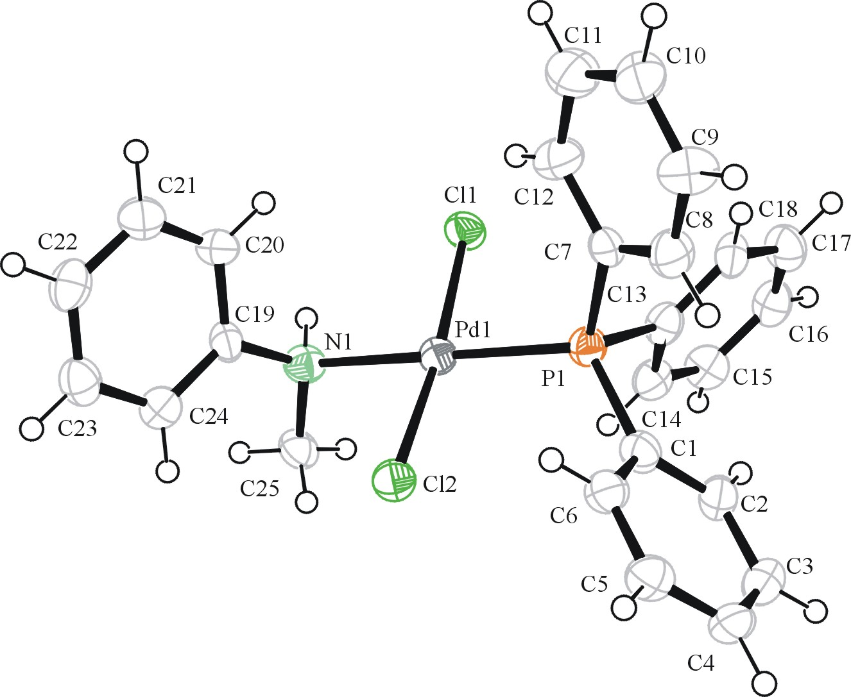
Figure 1. ORTEP drawing of complex 1 with thermal ellipsoids at 50 % probability.

The space group of 1 is chiral where the crystals grew as enantiomorphic micro-twins and the specific sample used for the X-ray experiment was twinned with 0.58(5)% of the molecules with the structure shown in Figure 1 and the rest having the inverted structure. The aniline hydrogen H1 in 1 is hydrogen bonding to one of the chlorines. The planar tetragonal coordination of the palladium is slightly distorted by the hydrogen bond to an angle of N-Pd-Cl (H-bond) = 86.8º whereas the other angle N-Pd-Cl = 89.4º shows almost no distortion because the hydrogen atoms of the methyl group are too far apart to hydrogen bond to this chlorine. The hydrogen on N in addition is almost perfectly in the plane through Cl1, Cl2, N1, P1. This plane is slightly tetrahedrally distorted, with the angles Cl-Pd-Cl: 174.09º and N-Pd-P: 175.9º.
The methyl is placed between one intra- and two inter-molecular chlorines, as shown in the packing diagram, Figure 2.
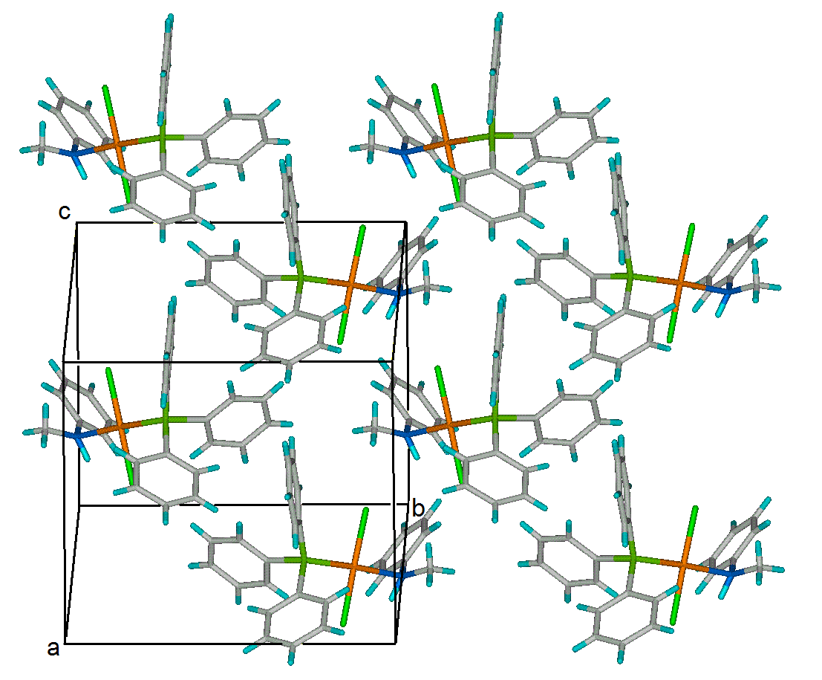
Figure 2. Packing diagram of the structure of complex 1.

Table2 shows that the hydrogen(s) on the aniline and the cyclohexaneamine cause a similar N-Pd-Cl (H-bond) angular distortion in complex 2 (figure 3) and both molecules in 6 (figure 5). However, the distortion of the opposing N-Pd-Cl angle is in the opposite directions compared with 1 because of no suitable partner for hydrogen bonding or Van der Waals interactions. Instead the tolylphosphines act as attractor for these chlorines. The packing diagram in figure 4 indicates that one of the toluene methyls filles the space between chlorines similar to the methyl in 1. The only translational symmetry element (c-glideplane) in 1 causes the molecules to direct almost in one direction.

Table2. Bond angles (Degrees) of the complexes of which structures are available.

complex | ∠N-Pd-Cl (H-bond) | ∠N-Pd-Cl | ∠Cl-Pd-Cl | ∠N-Pd-P
1 | 86.8(2) | 89.4(2) | 174.09(9) | 175.9(2)
2 | 86.38(13) | 93.58(5) | 173.61(5) | 174.42(10)
6a | 85.59(11) | 91.47(5) | 174.90(5) | 174.38(11)
6b | 85.33(12) | 92.32(12) | 176.86(5) | 178.99(13)

Table 3. Specified hydrogen bonds (Å).
Complex | D-H | H...A | D...A | ∠ (DHA)
1 | 0.97(10) | 2.29(10) | 3.078(8) | 137(8) | N1-H1...Cl1
2 | 0.80(6) | 2.66(6) | 3.051(5) | 112(5) | N1-H1...Cl2
6a | 0.81(6) | 2.80(6) | 3.048(5) | 100(4) | N1-H1A...Cl2
6a | 0.81(6) | 2.78(5) | 2.955(5) | 94(4) | N1-H1A...Cl3
6a | 0.77(5) | 2.59(6) | 3.345 (5) | 165(6) | N1-H1B...Cl2_$1
6b | 0.81(6) | 2.70(6) | 3.019(5) | 105(4) | N2-H2B...Cl4
6b | 0.81(6) | 2.62(6) | 3.002(5) | 111(5) | N2-H2B...Cl6
6b | 0.96(6) | 2.41(6) | 3.330(5) | 158(4) | N2-H2A...Cl4_$2
Intermolecular symmetries: $1= -x, -y+1, -z+1; $2= -x+1, -y, -z

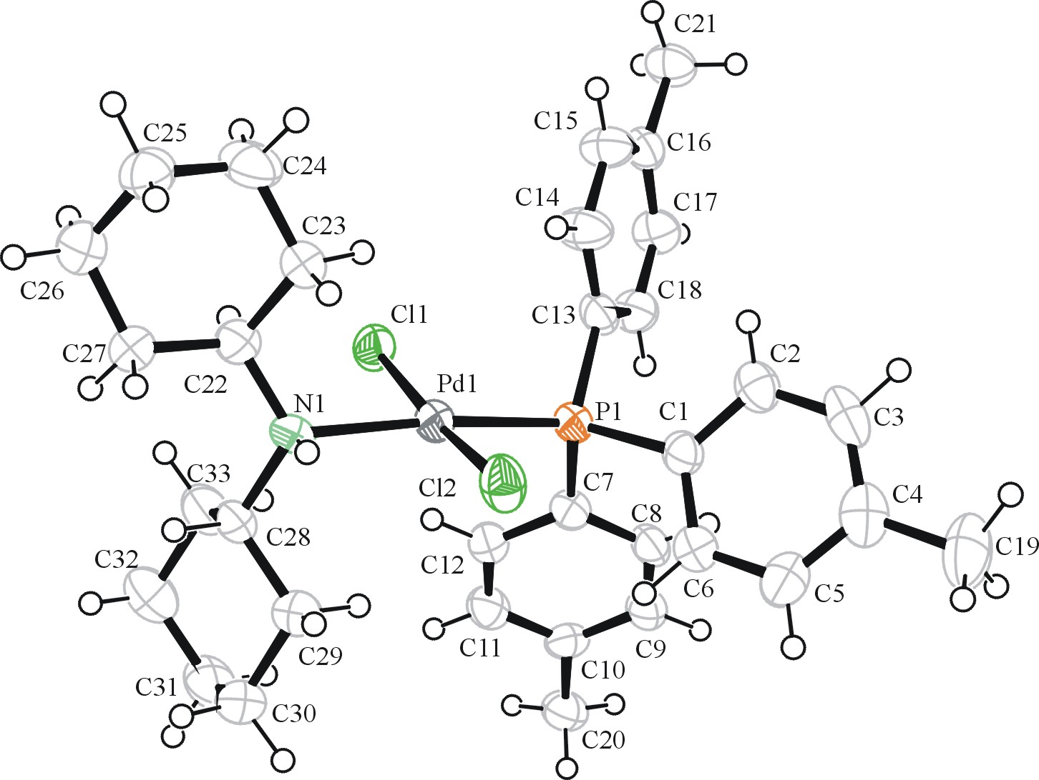
Figure 3. ORTEP drawing of complex 2 with thermal ellipsoids at 50 % probability.

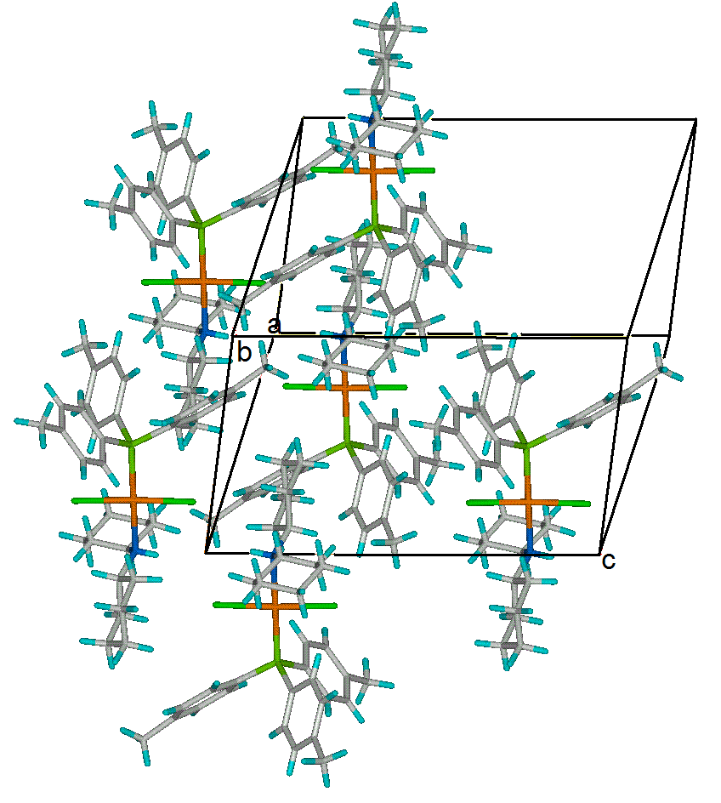
Figure 4. Packing diagram of the structure of complex 2.

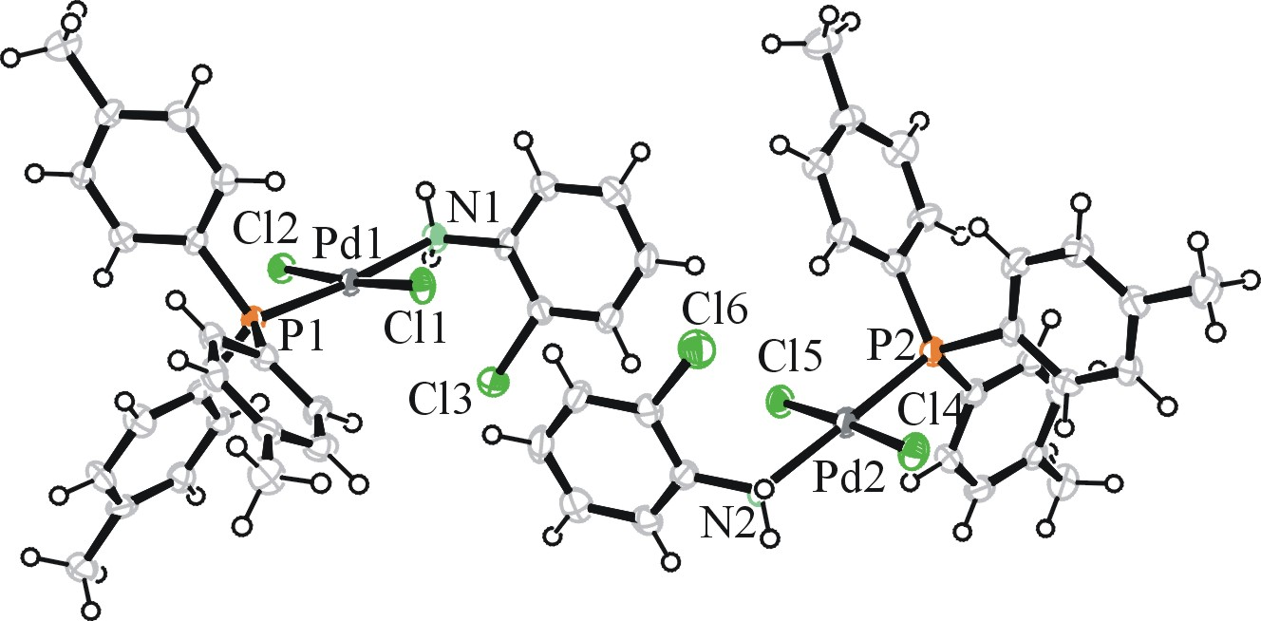

Figure 5. ORTEP drawing of complex 6 with thermal ellipsoids at 50 % probability.

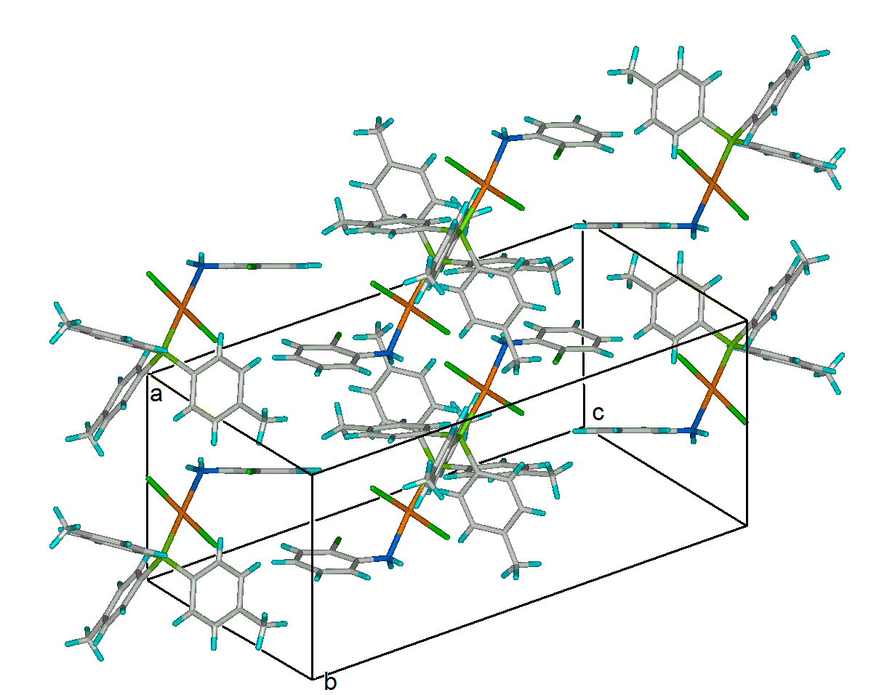

Figure 6. Packing diagram of the structure of complex 6.

The two symmetry independent molecules of the asymmetric unit in 6 (6a, 6b) show similar hydrogen bonding characteristics. The 2-chloro aniline hydrogens interact with the 2-chloro and one of the chlorines on the palladium intramolecularily as well as intermolecularly with chlorines of neighboring molecules (figure 6).

Table 4. Bond distances to palladium.

Comple1 | Pd-N | Pd-P | Pd -Cl (H-bond) | Pd-Cl
1 | 2.160(7) | 2.2572(23) | 2.3112(22) | 2.2833(22)
2 | 2.160(4) | 2.2446(14) | 2.2921(15) | 2.2882(15)
6a | 2.165(4) | 2.2332(13) | 2.3123(12) | 2.2777(12)
6b | 2.143(4) | 2.2287(14) | 2.3017(13) | 2.2903(13)

The planar tetrahedral coordinated bonds of the Pd(II) show very little variation between the molecules, with the exception of 6b which exhibits a significant shorter bond of the aniline nitrogen to the metal. In all other cases is observed that the hydrogen bonding between chlorines and nitrogen (Pd-Cl1) enlarges the bond distance compared with that of the non-intramolecularly hydrogen bonding chlorines

3.3 Catalytic Activity
All synthesized palladium (II) complexes were investigated for their catalytic behavior towards ethylene oligomerization. Methylaluminoxane (MAO) was selected as cocatalyst. As shown in table (5), reaction parameters like time, temperature, pressure and concentration of catalyst were kept constant to have a comparable study. Results reveal that by keeping the p-tolyl phosphine ligand constant and changing substituted aniline significantly changes the catalytic activity. Activity is increasing in the following order: 2 < 1 < 4 < 6 < 3 < 5.
In case of chloro substituted aniline the activity increases indicating that a changed ligand environment around the metal is tuning the activity of the complexes. Thus, the architecture of these complexes plays indeed a significant role in oligomerization. The produced oligomers mainly consisted of butene. The activity of 2 which consists of cyclohexanes is 0.7 × 10⁴ which is less than that of other catalysts. This could indicate that increased aromaticity of ligands is beneficial. However, it is clear from our results that chlorine substituted aniline containing catalysts have a higher activity. A plausible explanation is that electron withdrawing chlorine groups on aniline might create an electron deficiency on the metal center. As a result the metal acts as a more active site so more electrophilic metal center might exhibit higher activity. Moreover, a complex structure favors chain transfers resulting in oligomer production.
The effect of the Ph₃P as auxillary ligand on catalytic activity was studied as follows: Two experiments were carried out to investigate the role of Ph₃P. Firstly, Ph₃P was added before addition of the co-catalyst and secondly, Ph₃P was added after addition of the co-catalyst. A pronounced increase in activity to 2.1×10⁴ gmol⁻¹(Pd)atm⁻¹hr⁻¹ was measured in the second experiment. The exact functionality of the auxiliary ligand Ph₃P is subject to further studies.

Table 5.
Entry No. Precursor [MAO]/[Pd] Temp(ºC) Activity*
1 1 500 25 1.0
2 2 500 25 0.7
3 3 500 25 1.5
4 4 500 25 1.3
5 5 500 25 1.6
6 6 500 25 1.4
7 1*¹ 500 25 1.2
8 1*² 500 25 2.1

Reaction conditions: *10⁴gmol⁻¹atm⁻¹hr⁻¹; time = 30min; 5μmol Pd;
pressure = 1 atm ethylene; 30mL toluene, C1*¹= Ph₃P was
added before cocatalyst addition, C1*²= Ph₃P was added after
MAO addition

4. Conclusion:
A series of six different palladium (II) catalysts were synthesized and characterized via NMR, IR spectroscopy and X-ray crystallographic studies. The new compounds have displayed moderate activity towards ethylene oligomerization. However, in six complexes, different substituents of ligands showed pronounced differences of catalytic activity indicating the importance of the complex architecture on the catalytic effect. Further work is under way on palladium (II) catalysts containing N, Ń bidentate ligands to explore the new avenues in the field of catalysis.

Acknowledgement:

The authors wish to acknowledge the financial support of higher education commission Pakistan vide project no.20-623 / R & D/06/2519. In addition we thank Prof. Wen-Hua Sun Professor of Catalysis at Institute of Chemistry, CAS, Beijing for his valuable guidance and sharing knowledge.
Supporting Information: The CIF files for the crystal structures of 1, 2 and 6 are available free of charge on application to CCDC, Cambridge, UK (Fax: +44 1223336033; deposit@ccdc.com.as.uk).

Reference: ? Johnson, L.K., Killian, C. M., Brookhart. M., J. Am. Chem. Soc., 117 (1995) 6414- 6415.
Feldman, J., McLain, S. J., Parthasarathy, A., Marshall, W. J., Calabrese, J. C. and Arthur S. D., Organometallics, 16 (1997) 1514-1516.
(a) Drent, E., Pure Appl. Chem. 62 (1990) 661. (b) Brookhart, M. Rix, F. C., Desimone, J. M., Barborak, J. C. , J. Am. Chem. Soc., 114 (1992) 5894. (c) Rix, F. C., Brookhart, M., J. Am. Chem. Soc., 117 (1995) 1137.
Meneghetti, S. P., Lutz, P. J., Kress J., Organomet., 18 (1999) 2734-2737.
Chen, R., Bacsa, J., Selwyn, M. F., Inorg. Chem. Commun., 5 (2002) 724-726.
Chen, R., Selwyn, M. F., J. Mol. Catal. A.: Chemical 193 (2003) 33-40.
Mohlala, M. S., Guzei, I. A., Darkwa, J., Selwyn, M. F., J. Mol. Catal. A.: Chemical 241 (2005) 93-100.
Ilia, G. A., Kelin, L., Galina, B. A., James D., Selwyn, M. F., Dalton Trans., (2003) 715- 722
Camacho, D. H., Salo, E. V., Guan, Z., Ziller, J. W., Organomet., 24 (2005) 4933-4939
Jezreel, C., Selwyn, M. F., J. Mol. Catal. A: Chemical 243 (2006) 221-225.
Burrows, A. D., Mahon, M. F., Varrone, M., Dalton Trans., (2003) 4718-4730. (b). Majourne, F., Lonnecke, P., Novikova, E. V., Belov, G. P., Hey-Hawkins E., Dalton Trans., (2005) 3326-3330 (c). Sirbu, D., Consiglio, G., Milani, B., Kumar, P.G.A., Pregosin, P.S., Gischig, S., J.Organomet.Chem. 690(2005)2254-2262.
Sauthier, M., Leca, F., Toupet, L., Reau, R, Organomet., 21 (2002) 1591-1602
Shi, P. Y., Liu, Y. H., Peng, S. M., Liu, S.T., Organomet., 21 (2002) 3203-3207
Tempel, D. J., Johnson, L.K., Huff, R. L., White, P.S., Brookhart, M., J .Am Chem. Soc., 122 (2000) 6686-6700
Liu, W., Malinoski, J. M., Brookhart, M., Organomet., 21 (2002) 2836- 2838.
William, B.S., Leatherman, M.D., White, P.S., Brookhart, M., J. Am .Chem. Soc., 127 (2005) 5132-5146
Mecking, S., Johnson, L.K.., Wang, L., Brookhart, M., J. Am. Chem. Soc., 120 (1998) 888-899
Shultz, C.S., Ledford, J., Desimone, J.M., Brookhart, M., J.Am.Chem.Soc., 122 (2000) 6351-6356
Heinicke, J., Köhler, M., Peulecke, N., Keim, W., J.Cata., 225 (2004) 16-23
Armarego, W. L. F.; Chai, C. L. L.,“Purification of Laboratory Chemicals”, 5th Ed. Elsevier-Science, USA, 2003.
(a) Otwinowsky, Z. & Minor, W. (1997). Methods Enzyrnol. 276, 307-326. (b) Mackay, S.; Edwards, C.; Henderson, A.; Gilmore, C.; Stewart, N.; Shankland, K.; Donald, A.; MaXus, University of Glasgow, Scotland, 1997.
Altomare, A., Burla, C., Camalli M., Cascarano L., Giacovazzo C., Guagliardi A., Moliterni A.G.G., Polidori G., Spagna R. J. Appl. Cryst. (1999). 32, 115-119
Sheldrick, G. M.; SHELXL97 1997 University of Gottingen, Germany.
Waasmaier, D.; Kirfel, A.; Acta Crystallogr. A. 1995, 51, 416.
Farrugia, L. J.; Appl. Cryst. 1997, 30, 565.
(a) Nicola, C. D., Nogoune, J. , Effendy, A., Pettinari, C., Skelton, B. W., White, A. H., Inorganics Chimica Acta, 13 Feb, (2007) 2935-2943. (b) Asma, M., Badshah, A., Ali, S., Sohail, M., Fettouhi, M., Ahmed, S., Malik, A., Trans. Metal Chem, 31, 556-559, 2006. (c) Nakamoto, K., “Infra red and Raman Spectra of Inorganic and Coordination Compounds”, Part B, 5th edn. John Wiley and Sons, USA, 1997. (d) Pretsch, E., Bühlmann, P., Affolter, C., “Structure Dtermination of Organic Compounds”, Springer-Verlag Belin Heidelberg Germany 2000.
Ferraro, J. R., “Low-Frequency Vibratins of Inorganic and Corrdination Compounds”, Plenum Press, New York, 1971.
Abu-Surrah, A. S.; Thewalt, U.; Rieger, B., J. Organomet.Chem. 587 (1999) 58-66.
“Handbook of 1H-nmr spectra and data”,. Asahi Research Center Co., Ltd., Tokyo, Japan, page no. 246 vol.5, 1985.
Koide Y., Bott, S. G., Barron, A. R., Organomet., 15 (1996) 2213-2226.
Jutand, A., Negri, S., Principaud, A., Eur. J. Inorg. Chem. 2005, 631-635.
Pouchert, C. J. Campbell, J. R., “The Aldrich Library of NMR Spectra” vol. V, USA, 1974.
Johnson, LeyRoy F.; Jankowski, William C., “Carbon-13 NMR Spectra”, Varian Association, A Wiley-Interscience Publication, New York, 1972.
Kalinowski, H.O.; Berger, S.; Brown, S., 13C-NMR Spektroscopie, Thieme Verlag, Stuttgart, Germany, 1984

